# Example 1

File: Principal_Tension_Stress_Example_1.pgs

Girder: WF100G

Spacing: 5ft

Span Length: 210ft

$$t_{w}=6.125in$$

$$I_{g}=1524912.4in^{4}$$

$$I_{c}=2223257.4in^{4}$$

$$Y_{t}=51.726in$$

$$Y_{tc}=40.068in$$

$$W_{slab}=60in$$

$$t_{slab}=7.5in-0.5in=7in$$

Girder Concrete, $f_{ci}^{'}=7.5 ksi$, $f_{c}^{'}=10.1 ksi$, $E_{c}=6184.0 ksi$

Deck thickness: 7.5” with 0.5” sacrificial depth

Deck concrete: $f_{c}^{'}=4.0 ksi$, $E_{c}=4266.2 ksi$

Analyze Girder B at the critical section for shear

## Web Section at Composite Section Centroid

Compute first moment of area about the centroid of the composite section. Section geometry is shown in the sketch below.

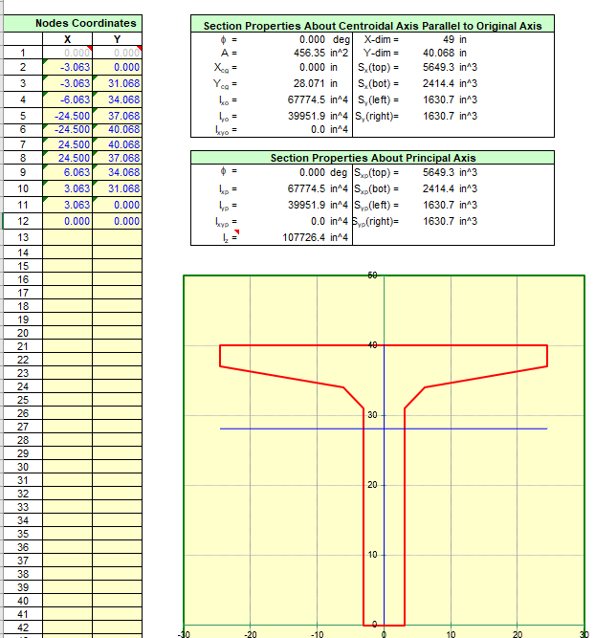

First moment of area of the non-composite section about the centroid of the composite section

$$Q_{nc}=\left(456.35in^{2}\right)\left(28.071 in+\left(51.726 in-40.068im\right)\right)=18130.3in^{3}$$

First moment of area of composite section about the centroid of the composite section. First compute the area and centroid of the composite girder section above the centroid of the composite section. Use the modular ratio to transform the slab concrete into equivalent girder material.

$$n=\frac{4266.2}{6184.1}=0.690$$

$$A=456.35in^{2}+0.690\left(60in\right)\left(7in\right)=745.15in^{2}$$

$$Y=\frac{\left(456.35in^{2}\right)\left(28.071in\right)+0.690\left(60in\right)\left(7in\right)\left(40.068in+\frac{7in}{2}\right)}{745.15in^{2}}=34.14 in$$

$$Q_{c}=\left(745.15in^{2}\right)\left(34.14in\right)=25439.4in^{3}$$

Flexural stress at critical section for shear - Service III + Prestress

We are seeking maximum principal tensile stress so we want the maximum tensile stress at the composite section centroid. If the stress is not tensile, we want the least compressive stress. This occurs when the live load moment is minimized. Note that we cannot simply take the Service III flexural stress demand. The flexural stress demands are compared to a tension limit. The bottom of the girder stress is maximized for the maximum live load moment case and the top of girder stress is maximized for the minimum live load moment case. The top and bottom stress reported from flexure do not occur for the same live load condition. We need the top and bottom stress to be from the same live load condition for the principal web stress check.

$$f_{top}=-1.428 ksi$$

$$f_{bot}=-2.917 ksi$$

Flexural stress at centroid of composite section

$$f_{pcx}=\frac{\left(-2.917ksi- -1.428ksi\right)}{100 in}\left(40.038 in\right)+ -1.428ksi=-2.024 ksi$$

Shear forces at critical section for shear

$$V_{girder}=116.7kip$$

$$V_{diaphragm}=6.87kip$$

$$V_{slab}=45.56 kip$$

$$V_{haunch}=11.16 kip$$

$$V_{barrier}=21.63 kip$$

$$V_{overlay}=15.44 kip$$

$$V_{LLIM}=147.87 kip/lane$$

$$g=0.596\frac{lanes}{girder}$$

$$γ_{LLIM}=0.8$$

NCHRP 849

$$V_{nc}=116.7+6.87+45.56+11.16=180.3 kip$$

$$V_{c}=21.63+15.44+0.8\left(0.596\right)\left(147.84\right)=107.6 kip$$

$$V_{p}=58.1kip$$

$$τ=\frac{\left(180.3kip-58.1kip\right)\left(18130.3in^{3}\right)}{(6.125in)(1524912.4in^{4})}+\frac{(107.6 kip)(25439.4in^{3})}{(6.125in)(2223257.4in^{4})}=0.438 ksi$$

$$f_{max}=\frac{1}{2}\left(f_{pcx}+\sqrt{f_{pcx}^{2}+{\left(2τ\right)}^{2}}\right)$$

$$f_{max}=\frac{1}{2}\left(-2.024ksi+\sqrt{{\left(-2.024ksi\right)}^{2}+4{\left(0.438ksi\right)}^{2}}\right)=0.091 ksi$$

LRFD

$$V_{u}=180.3+107.6=287.9kip$$

$$τ=\frac{\left(287.9kip-58.1kip\right)\left(25451.3in^{3}\right)}{\left(6.125in\right)\left(2225069.0in^{4}\right)}=0.429 ksi$$

$$f_{max}=\frac{1}{2}\left(-2.024ksi+\sqrt{{\left(-2.024ksi\right)}^{2}+4{\left(0.429ksi\right)}^{2}}\right)=0.087 ksi$$

## Web Section at Bottom Flange Fillet

Web section is 87.375” below top of non-composite girder. Compute first moment of area about the centroid of the bottom flange fillet. Section geometry is shown in the sketch below.

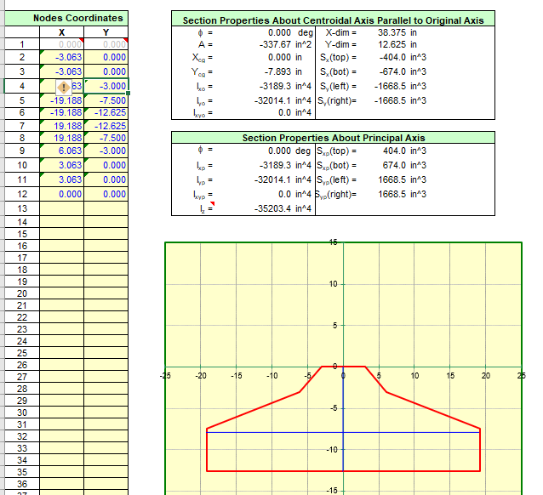

First moment of area of the non-composite section about the centroid of the composite section

$$Q_{nc}=\left(336.67in^{2}\right)\left(7.880 in+\left(48.274 in-12.625in\right)\right)=14654.9in^{3}$$

$$Q_{c}=\left(336.67in^{2}\right)\left(7.880 in+\left(59.932 in-12.625in\right)\right)=18579.8in^{3}$$

Flexural stress at critical section for shear - Service III + Prestress

We are seeking maximum principal tensile stress so we want the maximum tensile stress at the composite section centroid. If the stress is not tensile, we want the least compressive stress. This occurs when the live load moment is maximized.

$$f_{top}=-1.558 ksi$$

$$f_{bot}=-2.722 ksi$$

Flexural stress at centroid of composite section

$$f_{pcx}=\frac{\left(-2.722ksi- -1.558ksi\right)}{100 in}\left(87.375 in\right)+ -1.558ksi=-2.575 ksi$$

NCHRP 849

$$τ=\frac{\left(180.3kip-58.1kip\right)\left(14654.9in^{3}\right)}{(6.125in)(1524912.4in^{4})}+\frac{(107.6 kip)(18579.8in^{3})}{(6.125in)(2223257.4in^{4})}=0.338 ksi$$

$$f_{max}=\frac{1}{2}\left(f_{pcx}+\sqrt{f_{pcx}^{2}+{\left(2τ\right)}^{2}}\right)$$

$$f_{max}=\frac{1}{2}\left(-2.575ksi+\sqrt{{\left(-2.575ksi\right)}^{2}+4{\left(0.338ksi\right)}^{2}}\right)=0.044 ksi$$

LRFD

$$V_{u}=180.3+107.6=287.9kip$$

$$τ=\frac{\left(287.9kip-58.1kip\right)\left(18579.8in^{3}\right)}{\left(6.125in\right)\left(2225069.0in^{4}\right)}=0.313 ksi$$

$$f_{max}=\frac{1}{2}\left(-2.575ksi+\sqrt{{\left(-2.575ksi\right)}^{2}+4{\left(0.313ksi\right)}^{2}}\right)=0.038 ksi$$

# Example 2

File: Principal_Tension_Stress_Example_2.pgs

This is the same as example 1, except the bridge is now a 2 span continuous structure.

## Simple Span Analysis

Simple span analysis mode gives the same results as example 1

## Continuous Span Analysis

The continuous span forces near Abutment 1 are similar to simple span forces. We will examine the critical section near Pier 2.

This web section is 9” below the top of the non-composite girder.

Compute first moment of area. Section geometry is shown in the sketch below.

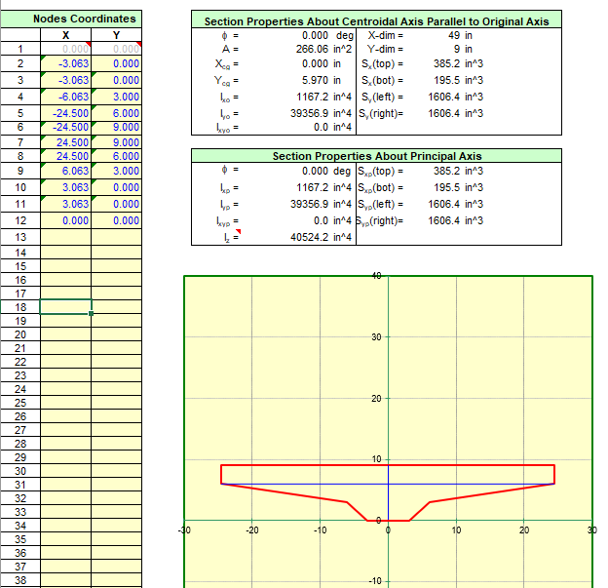

First moment of area about the non-composite section centroid

$$Q_{nc}=\left(266.06in^{2}\right)\left(5.970 in+\left(51.726 in-9in\right)\right)=12956.1in^{3}$$

First moment of area of the about the composite section centroid

$$A=266.06in^{2}+0.690\left(60in\right)\left(7in\right)=555.86in^{2}$$

$$Y=\frac{\left(266.06in^{2}\right)\left(5.970in\right)+0.690\left(60in\right)\left(7in\right)\left(9in+\frac{7in}{2}\right)}{555.86in^{2}}=9.374 in$$

$$Q_{c}=\left(555.86in^{2}\right)\left(40.068in+(9.374in-9in)\right)=22480.1in^{3}$$

Flexural stress at critical section for shear - Service III + Prestress

We are seeking maximum principal tensile stress so we want the maximum tensile stress at the web section. If the stress is not tensile, we want the least compressive stress. This occurs when the live load moment is negative.

$$f_{top}=-0.688 ksi$$

$$f_{bot}=-3.982 ksi$$

Flexural stress at web section

$$f_{pcx}=\frac{\left(-3.982ksi- -0.688ksi\right)}{100 in}\left(9 in\right)+ -0.688ksi=-0.984 ksi$$

Shear forces at critical section for shear. Note that the critical section for shear at Pier 2 is at 8.631 ft from face of support. For simple span analysis, the critical section was at 7.732ft from face of support. This explains why the shear forces are different from example 1. Also note that superimposed loads are applied to a continuous structure.

$$V_{girder}=115.58kip$$

$$V_{diaphragm}=6.96kip$$

$$V_{slab}=45.12 kip$$

$$V_{haunch}=11.06 kip$$

$$V_{barrier}=27.08 kip$$

$$V_{overlay}=19.33 kip$$

$$V_{LLIM}=165.42 kip/lane$$

$$g=0.596\frac{lanes}{girder}$$

$$γ_{LLIM}=0.8$$

NCHRP 849

$$V_{nc}=115.58+6.96+45.12+11.06=178.72 kip$$

$$V_{c}=27.08+19.33+0.8\left(0.596\right)\left(165.42\right)=125.28 kip$$

$$V_{p}=57.30kip$$

$$τ=\frac{\left(178.72kip-57.30kip\right)\left(12956.1in^{3}\right)}{(6.125in)(1524912.4in^{4})}+\frac{(125.28 kip)(22480.1in^{3})}{(6.125in)(2223257.4in^{4})}=0.375 ksi$$

$$f_{max}=\frac{1}{2}\left(f_{pcx}+\sqrt{f_{pcx}^{2}+{\left(2τ\right)}^{2}}\right)$$

$$f_{max}=\frac{1}{2}\left(-0.984ksi+\sqrt{{\left(-0.984ksi\right)}^{2}+4{\left(0.375ksi\right)}^{2}}\right)=0.127 ksi$$

LRFD

$$V_{u}=178.72+125.28=304.0kip$$

$$τ=\frac{\left(304.0kip-57.3kip\right)\left(22480.1in^{3}\right)}{\left(6.125in\right)\left(2225069.0in^{4}\right)}=0.407 ksi$$

$$f_{max}=\frac{1}{2}\left(-0.984ksi+\sqrt{{\left(-0.984ksi\right)}^{2}+4{\left(0.407ksi\right)}^{2}}\right)=0.147 ksi$$

## Envelope of Simple and Continuous Spans

Abutment 1 results are the same as Example 1.

Note that prestress losses are different between continuous and envelope analysis methods due to elastic gains for superimposed dead loads. This causes the Service III stress with prestress and Vp to be slightly different between the analyses.

We are seeking maximum principal tensile stress so we want the maximum tensile stress at the web section. If the stress is not tensile, we want the least compressive stress. This occurs when the live load moment is negative.

$$f_{top}=-0.693 ksi$$

$$f_{bot}=-4.045 ksi$$

Flexural stress at web section

$$f_{pcx}=\frac{\left(-4.045ksi- -0.693ksi\right)}{100 in}\left(9 in\right)+ -0.693ksi=-0.995 ksi$$

$$V_{girder}=115.65kip$$

$$V_{diaphragm}=6.96kip$$

$$V_{slab}=45.15 kip$$

$$V_{haunch}=11.06 kip$$

$$V_{barrier}=27.08 kip$$

$$V_{overlay}=19.33 kip$$

$$V_{LLIM}=165.36 kip/lane$$

$$g=0.596\frac{lanes}{girder}$$

$$γ_{LLIM}=0.8$$

NCHRP 849

$$V_{nc}=115.65+6.96+45.15+11.06=178.82 kip$$

$$V_{c}=27.08+19.33+0.8\left(0.596\right)\left(165.36\right)=125.28 kip$$

$$V_{p}=58.15kip$$

$$τ=\frac{\left(178.82kip-58.15kip\right)\left(12956.1in^{3}\right)}{(6.125in)(1524912.4in^{4})}+\frac{(125.28 kip)(22480.1in^{3})}{(6.125in)(2223257.4in^{4})}=0.374 ksi$$

$$f_{max}=\frac{1}{2}\left(f_{pcx}+\sqrt{f_{pcx}^{2}+{\left(2τ\right)}^{2}}\right)$$

$$f_{max}=\frac{1}{2}\left(-0.995ksi+\sqrt{{\left(-0.995ksi\right)}^{2}+4{\left(0.374ksi\right)}^{2}}\right)=0.125 ksi$$

LRFD

$$V_{u}=178.82+125.28=304.1kip$$

$$τ=\frac{\left(304.1kip-58.15kip\right)\left(22480.1in^{3}\right)}{\left(6.125in\right)\left(2225069.0in^{4}\right)}=0.406 ksi$$

$$f_{max}=\frac{1}{2}\left(-0.995ksi+\sqrt{{\left(-0.995ksi\right)}^{2}+4{\left(0.406ksi\right)}^{2}}\right)=0.145 ksi$$